Projector Calibration Procedure Verification

Owen Lu

Electroimpact Inc.

owenl@electroimpact.com

*Abstract*—Using the current projector model and LOESS curve fits to for correction, DACs can be calculated to 1-2 count precision. When comparing multiple data sets taken at different distances, however, there is a large systematic error that is observed when using one data set to calibrate and the other data set to verify. This large error is almost completely eliminated by adding 3 rotational degrees of freedom to the projector axes selected by an optimization engine. This paper describes the experimental procedure that will be used to generate the data at multiple depths using only one metrology based transform from wall space to projector space. Included are also the calibration method, the theoretical basis for the experiment and procedure to obtain data for the verification.

# Current Calibration Method

Currently, the method used to generate projector parameters from a single data set is described in the list below:

1. From the nominal projector, ray equations are solved for the theoretical positions of the mirrors
2. A least-squares linear curve fit is used to map DAC commands to the theoretical angles
3. An optimization for a rotational transform is solved to minimize errors
4. A pair of LOESS based curve fits are used to map theoretical DAC commands to observed commands

After these steps, the projectors parameters are fully defined. In the current model, 29 parameters describe the projector and 6 describe a coordinate transform of the projector relative to the frame that the 3D coordinates are measured in.

At this point, on a new data set, the coordinate transform that minimizes the squared DAC error is used. This is very similar to the certification procedure output currently implemented. However, all 3D coordinates are used to generate only a rotational transform.

# Theoretical basis of verification

Currently, it is known that estimating the rotational transform of the projector is prone to random error due to the distance between the machined targets compared to the precision of the laser tracker. Thus, if multiple data sets taken at different distances are used, there is a rotational transform characterized by quaternion $q$**for each data set**. This means that for each new data set, 3 new degrees of freedom are introduced that greatly impact the performance of the model.

However, if the projector were to remain stationary and targets at different nominal distances were scanned there would be a single transform for the projector, as it has not moved. Thus, we would expect that calibrating on two distances of targets, similar RMS error would result across both sets of targets. Currently, this is not true, and additional rotational transforms are used to compensate for this error. The validity of this method has not been assessed in detail so far to my knowledge.

# Elimination of metrology in calibration

It was previously brought to my attention that one competitor uses a technique calibrate the projector that is not based on metrology. Therefore, they must inherently solve for the 6 transform variables that define $(q,T)$ on each set to locate the projector in space for calibration.

Example:

Suppose 6 sets of data are used to calibrate the projector, then an extra 36 degrees of freedom to describe the 6 different positions/rotations of the projector.

The method I have used up to this point is very similar. For each data set, I have introduced instead 3 new variables describing purely the rotational transform of the projector.

On paper, if I use the 10FT data to calibrate the projector, and solve a transform on the 20FT, I can get 1-2 DAC count error. However, there is no way to verify whether this transform is physically correct, only that the DAC commands match very well. In practice, this quaternion results in a rotation matrix very close to the identity, which is re-assuring but not proof that it is correct.

I believe (without direct proof yet) that this method would tend to overstate the accuracy when the problem is to generate DAC commands from 3D coordinates. I will have to verify this later possibly with this experiment. **However, in principle, I am sure that with some tweaks a method that can be used to generate projector calibration without metrology is definitely within reach.**

# Assumptions

The assumptions listed indicate how I believe the tracking system and coordinate transform is implemented. If there are elements of this that are incorrect please let me know and I’ll review the experiment.

1. Tracker measures all targets within its own coordinate frame (wall targets/projector frame targets)
2. A transform is made to move all coordinates into the wall coordinate frame
3. Using targets measured on the projector, a transform to bring coordinates from the wall frame to the projector frame is calculated
4. The points are then brought into the projector frame
5. If multiple distances are scanned, steps 3-4 are repeated assuming the same locations of all wall targets.

If this is the current procedure, then for 2 data sets there are 3 transforms. One to bring the coordinates into the wall space and another to bring the wall space coordinates into projector space for each data set. From the previous discussion, the distance between targets on the projector frame is small possibly resulting in a relatively large error in the rotational transform. I believe that this is not true of the reference points on the wall that define the wall coordinates since the distance between targets is large compared to the random error in the laser tracker.

With this in mind, random error is introduced into the system twice, once for each data set when the rotation of the projector is considered. However, by setting the projector up in one location, and moving a wall of targets into the field of view and taking the data again, the random error is only introduced into the system once regarding the rotational transform. **This is the value of the experiment. Two or more different depths that have only one metrology based transform to move the points into the projector frame is possible with this new experiment.**

# Hypothesis

It has been shown with previously that calibrating using data points on one wall and then solving a transform for points at a different depth can be done to the precision of 1-2 DAC counts. This leads me to believe that the projector model is accurate in its current form. If this claim is true, then errors within the same range of 1-2 DAC counts should be achievable solving for a projector model across two different depths with one transform. If this is not possible, then there is some other error that is present with data points at different depths which is, possibly un-modelled, or not possible to resolve reasonably using the current optimization engines and objectives.

# Procedure

The procedure described is not exact in terms of distance specification since I am unsure of any implementation limitations. Ideally, there are three key points that should be present in the experiment listed below.

1. The projector should not move during the whole experiment
2. The targets on multiple walls should be approximately on planes 1FT from one another in the Z direction.
3. A large range of DAC angles should be tested, 10FT nominally seems to be reasonably good in terms of range and density of the DAC angles.

Preliminary procedure:

1. Set projector at approximately 10FT from the main calibration wall
2. Scan all targets and verify that DAC angles have not drifted
3. Truncate any data points with errors
4. Generate the transform of the projector and wall
5. Bring in the secondary wall of targets (probably around 20-30 targets) and place the wall approx. 1-2FT offset from the main calibration wall towards the projector
   1. Note: The targets must be positioned such that they lie within the range of the calibration DAC angles.
6. Scan secondary targets
7. If possible, offset the wall 1-2FT from its original position during the scan and rescan the targets.

After this is complete there should be one large data set with 3 sets of targets at different distances. Only one metrology based transform describing the projector frame should be present as the projector should not move. **I would like the data in the wall coordinates and in the projector coordinate frame for verification purposes. Therefore 2 sets of data should result.**

Regarding the 5.a, the constraint prevents extrapolation of the function used to correct the DAC angles that are found by using the model to calculate adjusted DAC from XYZ positions. For example, if the data set in blue shown below was used to calibrate, the secondary and tertiary targets must be placed such that the DAC angles resulting will be within the 2D red boundaries in Figure 1.

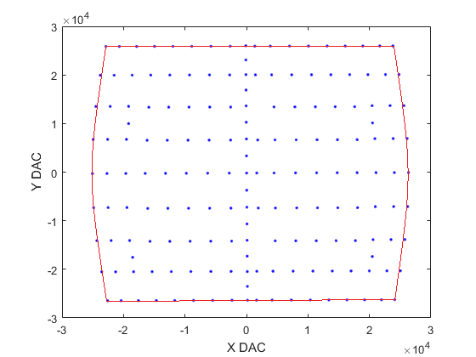

Figure – Boundary for DAC angles resulting from secondary/tertiary walls